**ARABIC PARTS (OR HERMETIC LOTS)**

Arabic Parts (or Hermetic Lots) is a form of astrological analysis dating back to Babylonian, Persian, Hermetic, or Magian astrology before the first century B.C. They are constructed through mathematical calculations using certain planets or angles in an astrological chart.

The Lot of Fortune (or Arabic Part of Fortune) is perhaps the most commonly discussed Arabic Part, which denotes the key or path to success.

The Part of Spirit, Part of Commerce, Part of Love, Part of Fatality, and about two dozen other Parts are considered in an Arabic Part analysis. I tend to focus on the Lot of Fortune and Lot of Spirit.

**The Lot of Fortune**

In traditional Hellenistic astrology, the Lot of Fortune, or Fortuna, was a crucial part of natal chart interpretation, though in modern interpretive approaches, it has fallen out of favor. The traditional method espoused in texts dating to 1 B.C. distinguishes between diurnal (day) and nocturnal (night) charts.

A geometric calculation is rendered by calculating the degrees between the sun and the moon, and then up from the ascendant for diurnal charts and from the moon to the sun, then from the ascendant for nocturnal charts. At least that’s how it was done traditionally in the First Century. Today, many astrologers will opt for an algebraic calculation (i.e., for diurnal charts: Ascendant + Moon — Sun; for nocturnal charts: Ascendant + Sun — Moon). I follow the traditional geometric method.

The Lot of Fortune indicates material well-being. It is your personal marker of success, the primary indicator of reaping prosperity in your life, and how you will achieve worldly success.

If you don’t see it in your natal chart, here’s how you calculate it:

[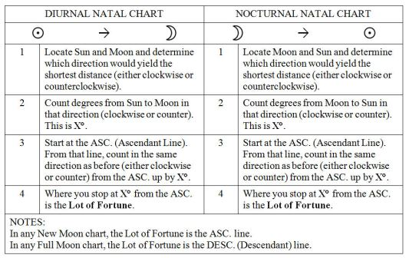](https://benebellwen.com/wp-content/uploads/2014/06/lot_of_fortune.jpg)

The Lot of Fortune is the indicator of the native’s primary or most optimal source of prosperity and material wealth. It’s, well, it’s how you can best make your fortune in this lifetime. Study the House and Sign placement for the Lot.

A Lot of Fortune appearing in House 2 could suggest finance, investments, business, the stock exchange, Wall Street; in House 4, perhaps by way of an inheritance or a family business; in House 3, through the native’s innate talents in communication, writing, public speaking, PR or marketing capabilities, etc.; House 1, by the native’s own merits, through entrepreneurship, founding an organization, or the native as an identified character *is*the marketable brand in some way, like a public figure.

If the Lot is in Aquarius, we’re looking at a native who works for the greater good in some way, *pro bono publico*and could make her mark in the community at large. If it’s in Leo with a strong Saturn aspect, a chief executive of some sort. If Gemini, here is someone who is going to talk his way to riches, through the art of negotiation and persuasion. If Cancer, a restaurateur, caterer, in e-commerce, real estate, a historian, anything food, hospitality, human services, land development, or health related would be an optimal path for material success. In Libra, art, fashion, architecture, or human services of some sort, education even. However, if there are strong Mercury or Saturn aspects, then perhaps law. When there’s a strong influence coming from Uranus, it will be by an unconventional path.

Also look at the aspects formed with the Lot and whether there is greater influence from beneficent or maleficent planets. Also, note the Sign that the Lot is in. Note the rulership of that Sign. Then locate that planet in the natal chart. The ongoings of that planet in the natal chart will have a significant impact on the native’s Lot. I will read the Lot of Fortune in conjunction with the midheaven (Mc) and House 10, especially if a native is looking for greater insights into her potential career path.

[**Your Hermetic Lot of Fortune (PDF)**](https://benebellwen.com/wp-content/uploads/2022/10/your-lot-of-fortune-sign-and-house-1.pdf)

A beginner’s handbook for interpreting the house and sign of your natal Lot of Fortune. After you’ve calculated the placement of Fortuna on your birth chart, look up the house and sign of your Fortuna in this handbook. Note whether there are any major conjunctions and look up the meanings accordingly. [CLICK HERE to download the MS Word docx version](https://benebellwen.com/wp-content/uploads/2022/10/your-lot-of-fortune-sign-and-house-1.docx).

line

**The Lot of Spirit**

While the Lot of Fortune energetic expresses influences on your material and physical planes, the Lot of Spirit expresses energetic influences on your intellectual and spiritual planes. Again, the traditional First Century method is geometric, as indicated in the chart below. However, note that many modern astrologers use an algebraic calculation (i.e., for diurnal charts: Ascendant — Moon + Sun; for nocturnal: Ascendant + Moon — Sun).

[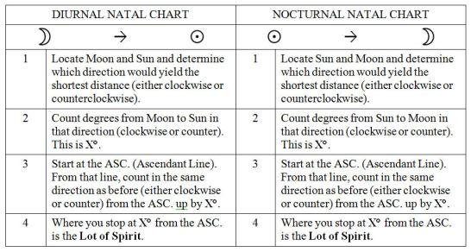](https://benebellwen.com/wp-content/uploads/2014/06/lot_of_spirit.jpg)

The Lot of Spirit indicates what animates you, the character your soul and spirit and how that character often manifests through the material and physical plane. So it’s an indicator of your motivations for success. Are you motivated to follow your Lot of Fortune to great material riches? Or are you more motivated to achieve self-actualization? The Lot of Spirit shows what’s within us that often emerges outward. It should be read closely in conjunction with the Lot of Fortune because the Lot of Spirit will explain the how and why for the Lot of Fortune.

Some also say the Lot of Spirit helps point us to our spirit guides and the character and essence of our spirit guides. We can get a better sense of who our spirit guides are by examining our Lot of Spirit.